Full stack notes by jhangir:
HTML:
Basic tags: v13
Tag | Meaning | Looks
<strong> | Strong importance | Bold
<em> | Emphasized | Italic
<mark> | Highlight | Yellow highlight
<del> | Deleted text | Strikethrough
<ins> | Inserted | Underlined
<sub> | Subscript | H₂O (₂ goes down)
<sup> | Superscript | x² (² goes up)

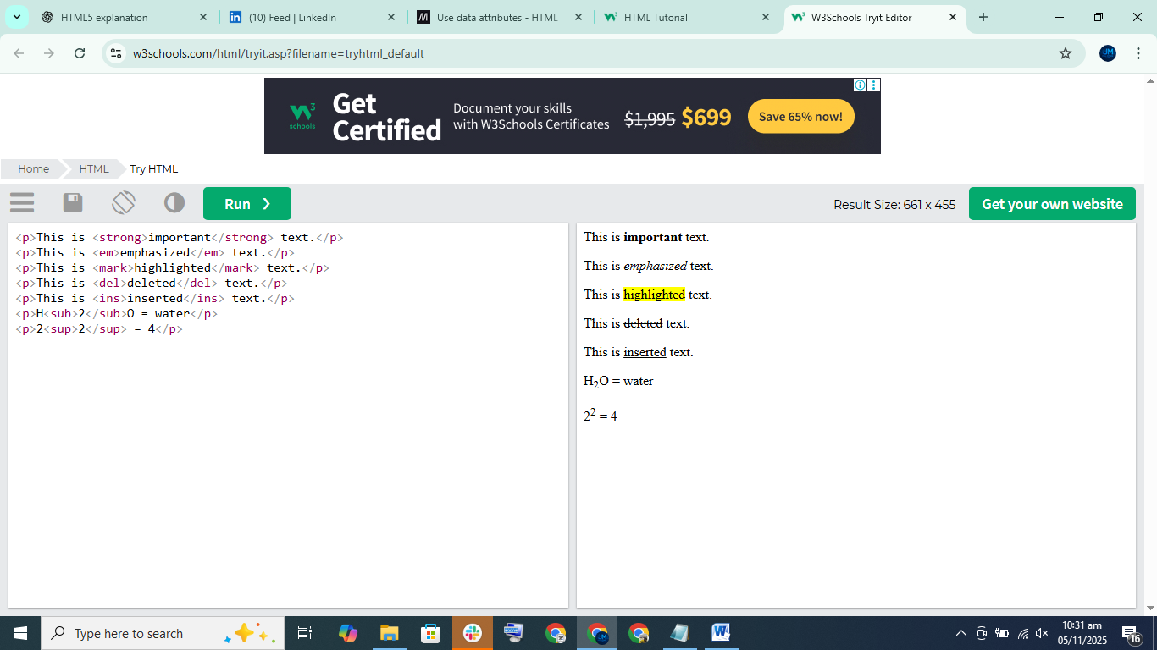

⚙ Shortcuts Learned
Shortcut | Function
! + Enter | Create full HTML template
Ctrl/Cmd + Enter | New line from anywhere
Ctrl/Cmd + / | Add comment
Shift + Alt + Down | Duplicate line
Ctrl/Cmd + + | Zoom in browser

What Are DevTools?
DevTools are built-in tools in browsers (like Chrome) that help developers inspect and edit web pages.
They help you see HTML, CSS, and behavior of a website.
You can open DevTools by:
- Right-click → Inspect
- Press F12
- Ctrl + Shift + I (Windows)
- Cmd + Option + I (Mac)

Ordered List Example
<h3>My Morning Routine</h3>
<ol>
<li>Wake up</li>
<li>Brush teeth</li>
<li>Drink water</li>
<li>Exercise</li>
</ol>
Output:
My Morning Routine
- Wake up
- Brush teeth
- Drink water
- Exercise

✅ Unordered List Example
<h3>Shopping List</h3>
<ul>
<li>Bread</li>
<li>Milk</li>
<li>Eggs</li>
<li>Butter</li>
</ul>
Output:
Shopping List
• Bread
• Milk
• Eggs
• Butter

✅ Description List Example
<h3>Web Terms</h3>
<dl>
<dt>HTML</dt>
<dd>Structure of a webpage</dd>

<dt>CSS</dt>
<dd>Styling of a webpage</dd>

<dt>JavaScript</dt>
<dd>Adds interactivity to a webpage</dd>
</dl>
Output:
Web Terms
HTML – Structure of a webpage
CSS – Styling of a webpage
JavaScript – Adds interactivity to a webpage

🎯 Tip
Use:
Tag | Purpose
<ol> | Ordered numbers
<ul> | Bullet points
<dl> | Definitions
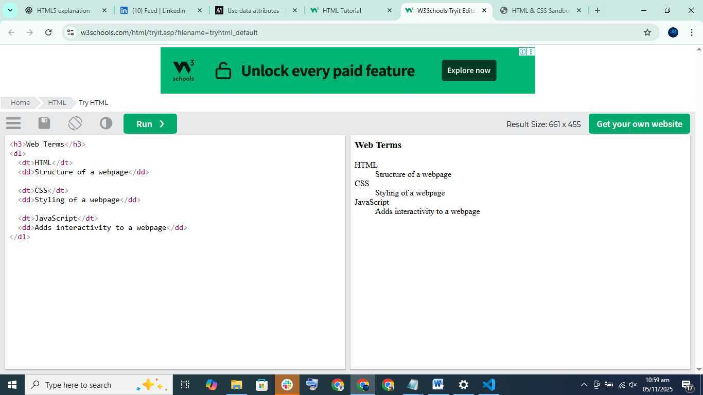

What are Anchor Tags?
Anchor tags (<a>) are used in HTML to create links. These links allow users to:
- Open other websites (external links)
- Move to other pages on the same website (relative/internal pages)
- Jump to a section on the same page
- Open email applications to send mail
- Download or open files like PDFs

✅ Key Types of Links Explained

1️⃣ External Link
Used to open other websites.
<a href="https://google.com">Visit Google</a>
📝 Opens Google in same tab
To open in a new tab:
<a href="https://google.com" target="_blank">Visit Google</a>

2️⃣ Relative/Internal Page Link
Link to another page inside the same website folder.
<a href="about.html">About Page</a>

3️⃣ Internal Section Link (Jump to Section)
Move to a section on the same page.
<a href="#services">Go to Services</a>

<p id="services">This is services section.</p>

4️⃣ Email Link
Open the default email app to send email.
<a href="mailto:example@example.com">Send Email</a>

5️⃣ File Download Link
Link to open/download a file like PDF.
<a href="invoice.pdf">Download Invoice</a>

🏷️ Title Attribute
Shows tooltip when hovering.
<a href="about.html" title="About Our Company">About Page</a>

💡 Extra Notes
- href = link location
- target="_blank" opens link in new tab
- Internal navigation uses #sectionID
- Use anchor tags for menus, buttons, and navigation links

📌 Real-World Example Navigation Menu
<nav>
<a href="index.html">Home</a>
<a href="about.html">About</a>
<a href="services.html">Services</a>
<a href="contact.html">Contact</a>
</nav>

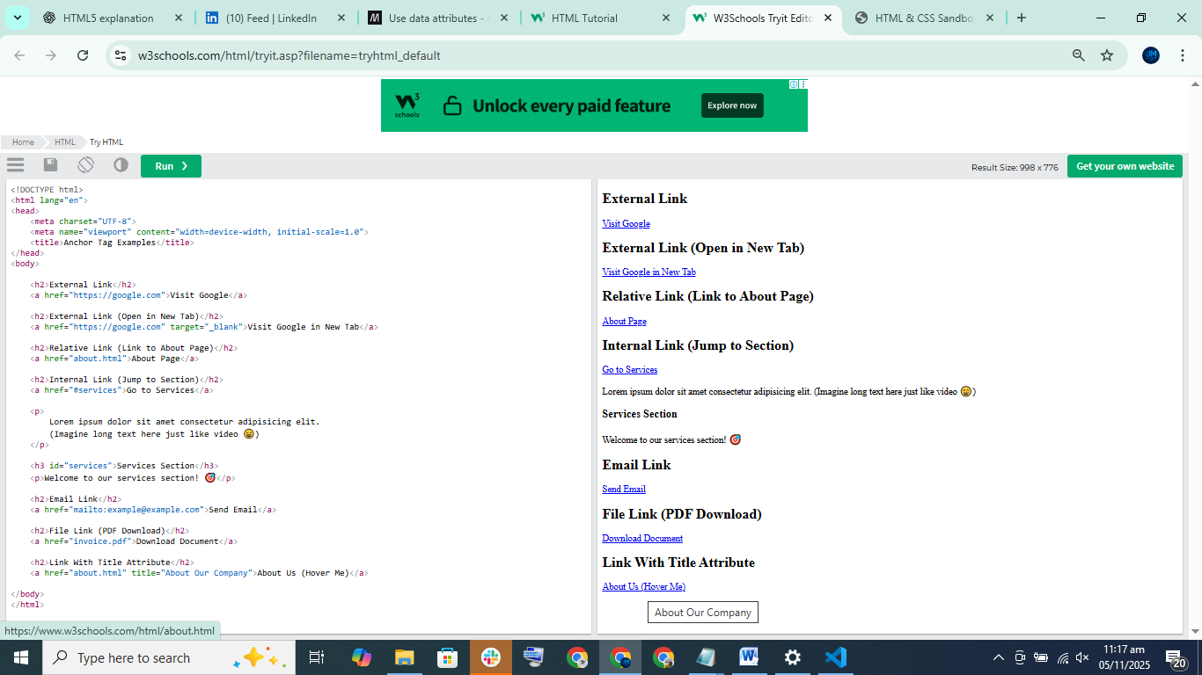

🖼️ HTML Image Tag (<img>) Explained
In HTML, we use the <img> tag to show images on a webpage.
This tag is self-closing (means it doesn't need a closing tag).
✅ Basic Syntax
<img src="image.jpg" alt="My Image">

📌 Important Attributes
Attribute | Meaning
src | The path/location of your image
alt | Text shown if image can’t load (also used for accessibility)
width & height | Set image size (but usually done in CSS)
title | Shows text when you hover over image

🎯 Example: Display Local Image
Folder structure:
project/
└── images/
└── landscape.jpg
Code:
<img src="images/landscape.jpg" alt="Landscape">

✨ Broken Image Example (Alt Text Shows)
<img src="images/notfound.jpg" alt="Landscape">
If file doesn't exist → browser will show the alt text.

🌍 Absolute Image URL Example
<img src="https://picsum.photos/200/300" alt="Random Image">
This loads a random image from the web.

📏 Setting Width & Height (not recommended in HTML)
<img src="images/landscape.jpg" width="400" height="300" alt="Landscape">
Better to use CSS later for styling.

🏷️ Add Title Tooltip
<img src="images/landscape.jpg" alt="Landscape" title="Beautiful Landscape">
Hover → shows tooltip text

🖼️ figure & figcaption
Used for images with descriptions/captions
<figure>
<img src="images/landscape.jpg" width="400" height="300" alt="Landscape">
<figcaption>Fig.1 – Beautiful Landscape</figcaption>
</figure>

✅ Key Points to Remember
- <img> = shows an image
- Must include src & alt
- Broken image → alt text appears
- Use CSS for styling images
- figure + figcaption = image with caption
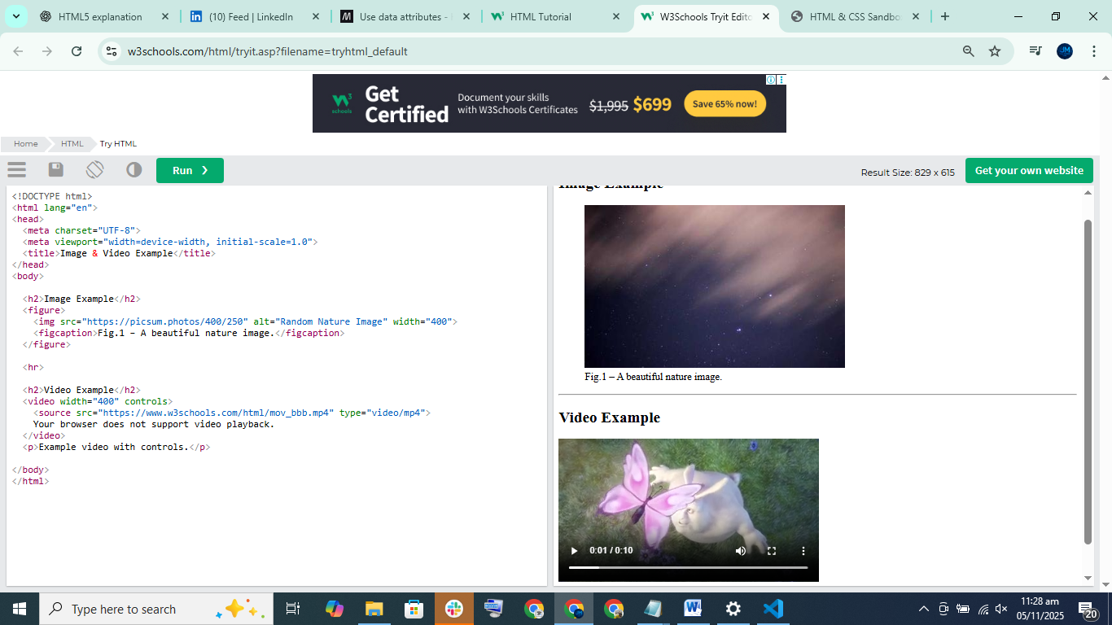

✅ Block-Level vs Inline Elements (Easy Explanation)

Block-Level Elements
✔ Always start on a new line
✔ Take up the full width available
✔ Push the next element to the next line
✔ Allow top & bottom margin
Examples:
<div>, <p>, <h1> - <h6>, <ul>, <ol>, <li>, <section>, <article>, <header>, <footer>, <form>, <table>
💡 Think of block elements like big blocks that take the full row.

Inline Elements
✔ Do not start a new line
✔ Only take the needed width
✔ Sit side-by-side
✔ Can only have left/right margin, not top/bottom
Examples:
<span>, <a>, <img>, <strong>, <em>, <button>, <input>, <label>, <small>
💡 Think of inline elements like text characters — they appear in the same line.
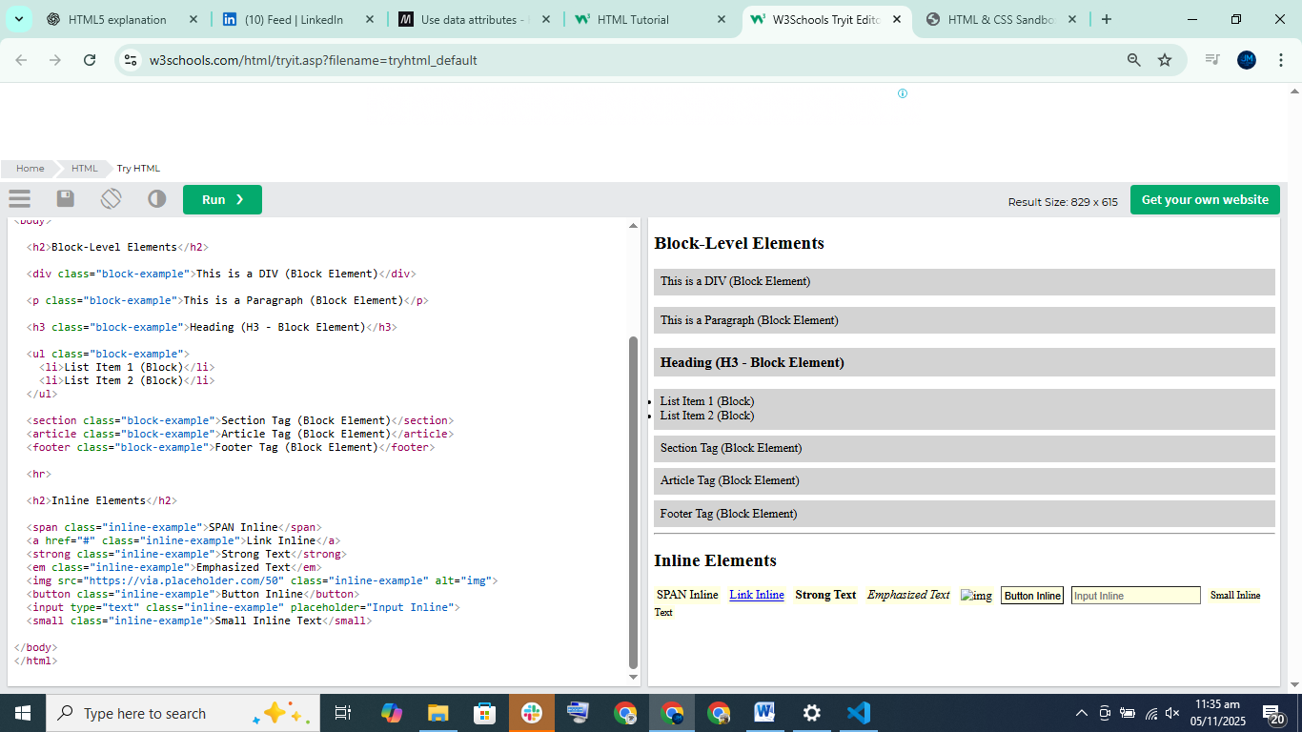

1️⃣ Line Break (<br>)
- Used to move text to a new line.
- Example:
Hello<br>World
- Tip: Only use <br> for text line break — not for spacing (use CSS padding/margin for space).

2️⃣ Horizontal Line (<hr>)
- Creates a horizontal divider line between content.
<p>First paragraph</p>
<hr>
<p>Second paragraph</p>
- Tip: Don’t use <hr> for layout, use CSS instead.

3️⃣ <pre> Tag (Preformatted Text)
- Shows text exactly how you type it, including spaces, tabs, and new lines.
<pre>
Hello World
Indented text
</pre>

4️⃣ <code> Tag (Code Snippets)
- Used to display code in HTML.
<code>console.log("Hello")</code>

5️⃣ HTML Entities
Used to show special characters in browser.
Character | Entity
< | &lt;
| &gt;
Copyright © | &copy;
Trademark ™ | &trade;
Non-breaking space | &nbsp;
Example — showing <h1> as text:
&lt;h1&gt;This is a heading&lt;/h1&gt;

🎯 Main Points to Remember
- <br> → new line
- <hr> → horizontal line
- <pre> → preserves text formatting
- <code> → shows code
- Entities allow you to display HTML characters like < > ©
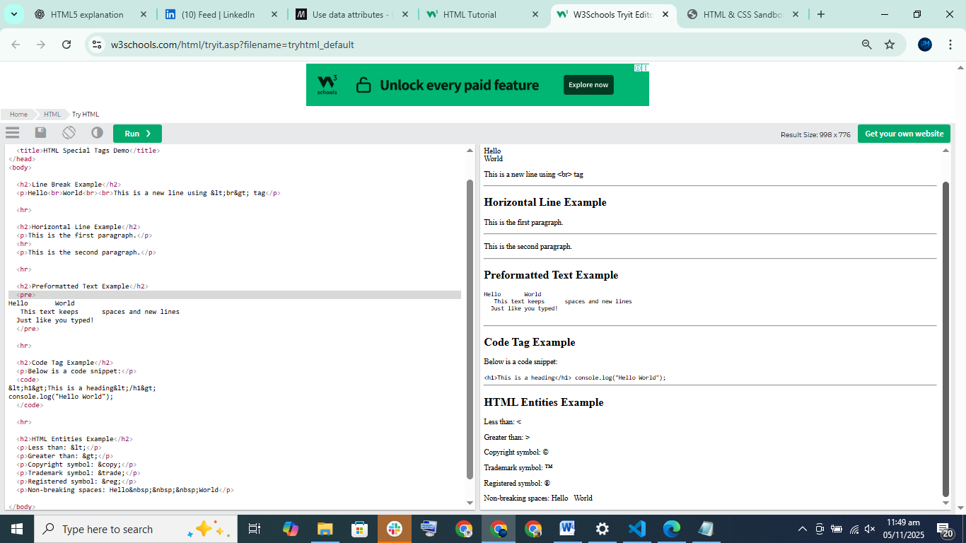

Video 20

What You Learned in This Video

📦 DIV (Block-level container)
- <div> is used to group big blocks of content.
- It always starts on a new line.
- Used to create sections like header, footer, blocks, cards, sections on websites.
- Most websites use divs everywhere to structure pages.
Example use:
- Wrap header
- Wrap navigation menu
- Wrap sections and paragraphs
- Wrap footer

🧵 SPAN (Inline container)
- <span> is for small text styling inside a line.
- It does not break the line.
- Used to style only part of text (color, bold, highlight)

🧠 Simple Rule
Tag | Use for
<div> | Big sections / Layout blocks
<span> | Styling small words inside a sentence

✅ Example Websites
They showed how websites like Netlify wrap boxes, cards, sections using DIV.

💡 Why we use them
To organize HTML and later apply:
- CSS
- Layout styles
- Colors, spacing, borders

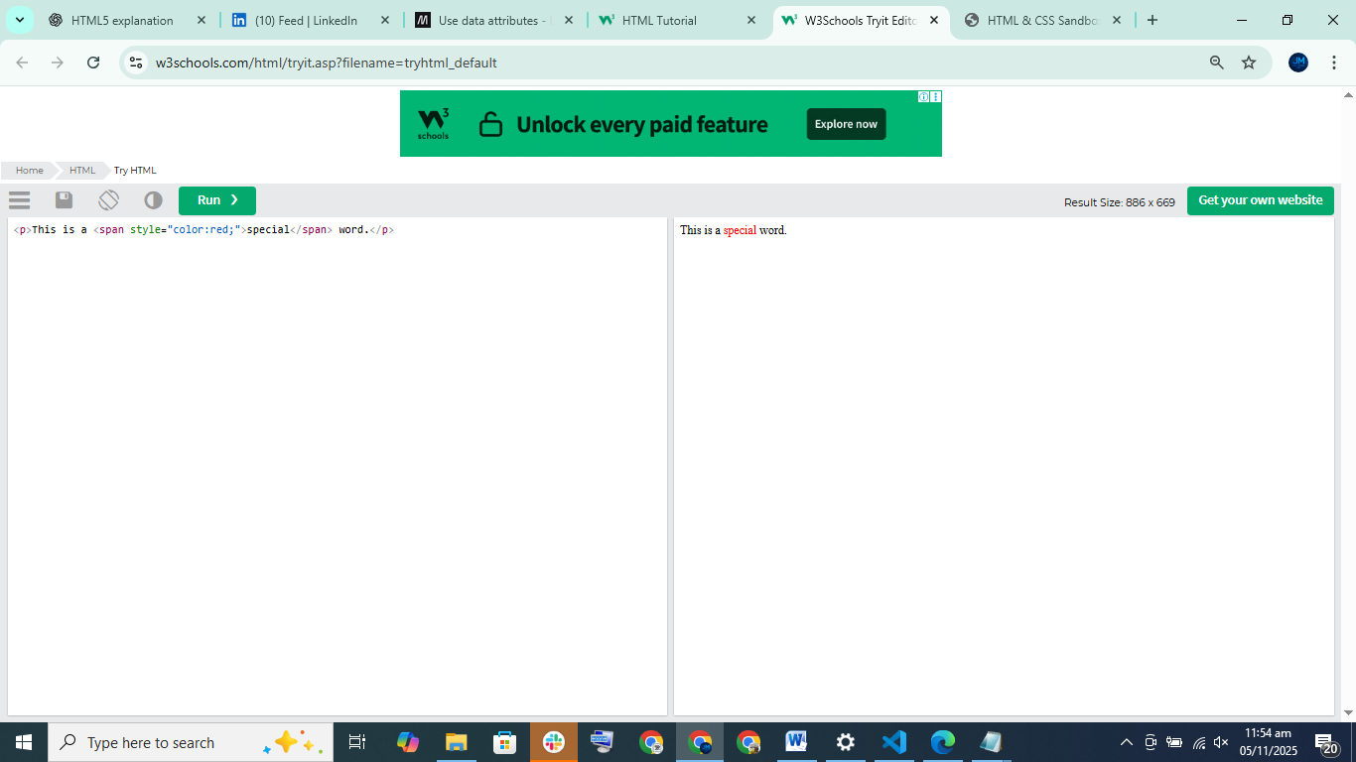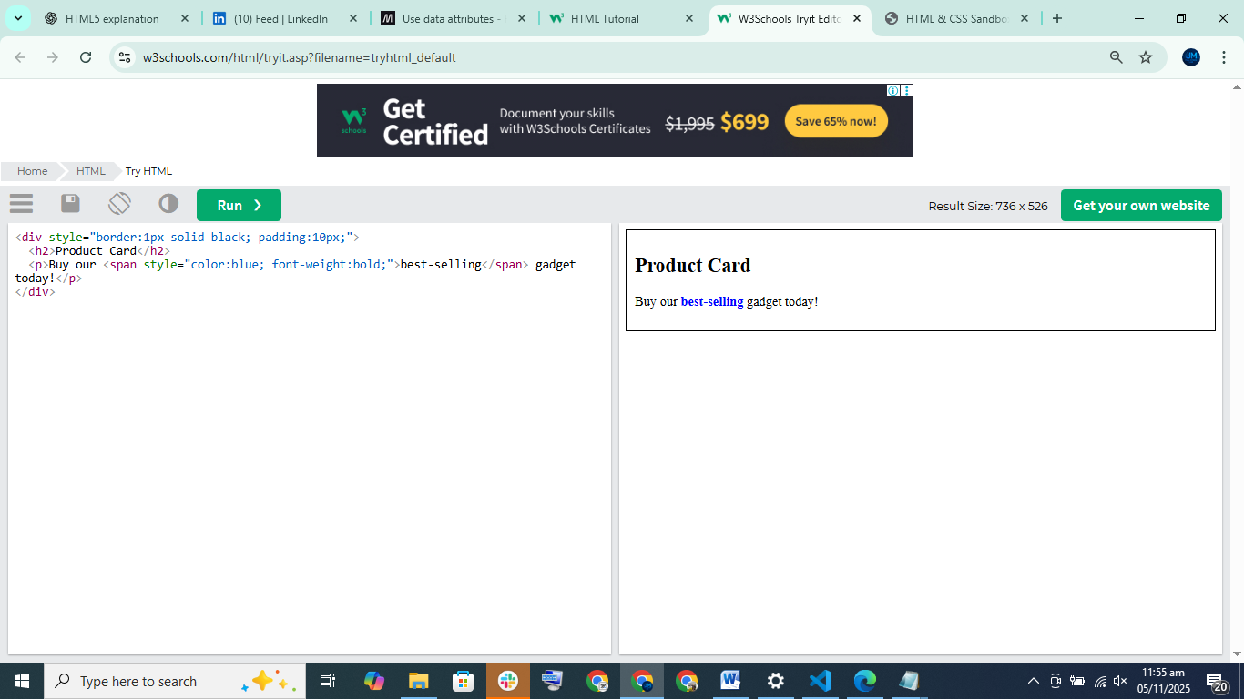🧠 Memory Trick
Think like this
DIV = Room in a house 🏠
SPAN = Word highlighted in a book ✏️

📌 Pro Tip
In modern development we also use:
- <section>
- <header>
- <footer>
- <article>
But DIV is still used everywhere, especially in CSS frameworks (Bootstrap, Tailwind, etc.).

Classes & IDs help us identify HTML elements
HTML elements can have:
Attribute | Purpose
class | Used to style multiple elements (repeatable)
id | Used for unique element on the page (one-time)

🧾 Class (class="")
✔ Used when you want to style or target many elements
✔ Reusable — you can apply the same class to multiple elements
✔ Mostly used for CSS styling
Example:
<div class="card text-center">Content Box</div>
<div class="card text-center">Another Box</div>
Here card and text-center can be reused many times.

🆔 ID (id="")
✔ Used when you want to target ONE specific element
✔ Should be unique (only one per page)
✔ Mostly used for JavaScript or page anchor links
Example:
<div id="header">Website Header</div>
This ID will be used only once.

💡 Developer Best Practice (from video)
For | Use
CSS | Classes ✅
JavaScript | IDs ✅ or Classes ✅ but ID preferred
One-time element | ID ✅
Repeat elements | Class ✅

✅ Real Examples (like instructor showed)

🖼 Classes for reusable styles
<div class="card text-center"></div>
<div class="card text-center"></div>

🔗 ID for unique sections
Used for scrolling to a section (like About page link)
<a href="#about">About</a>

<section id="about">About section</section>

🧠 Simple Memory Trick
Feature | CLASS | ID
Use-case | Repeatable | Unique
Count | Many | Only One
Used for | CSS Styling | JavaScript / Links
Symbol in CSS | . class | # id

🎨 Example With Both
<div class="card" id="header">
<h2 class="text-lg">Welcome</h2>
<p class="primary-text">Hello User</p>
</div>

📦 Extra Tip from video
- You can use class + id together on same element (but not always needed)
- You can bring elements to JavaScript with class or id
- Semantic tags (like <header>, <footer>, <nav>) coming next topic

✅ Summary in Simple English
Classes = Many elements, reusable, for styling
ID = One element, unique, for JavaScript & page navigation
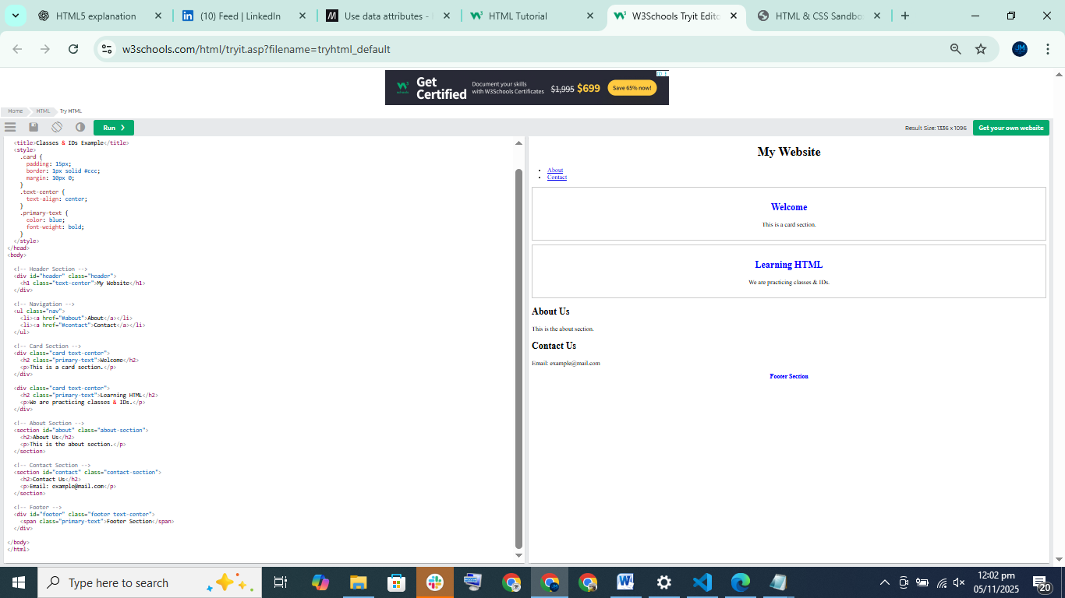

Vid 21

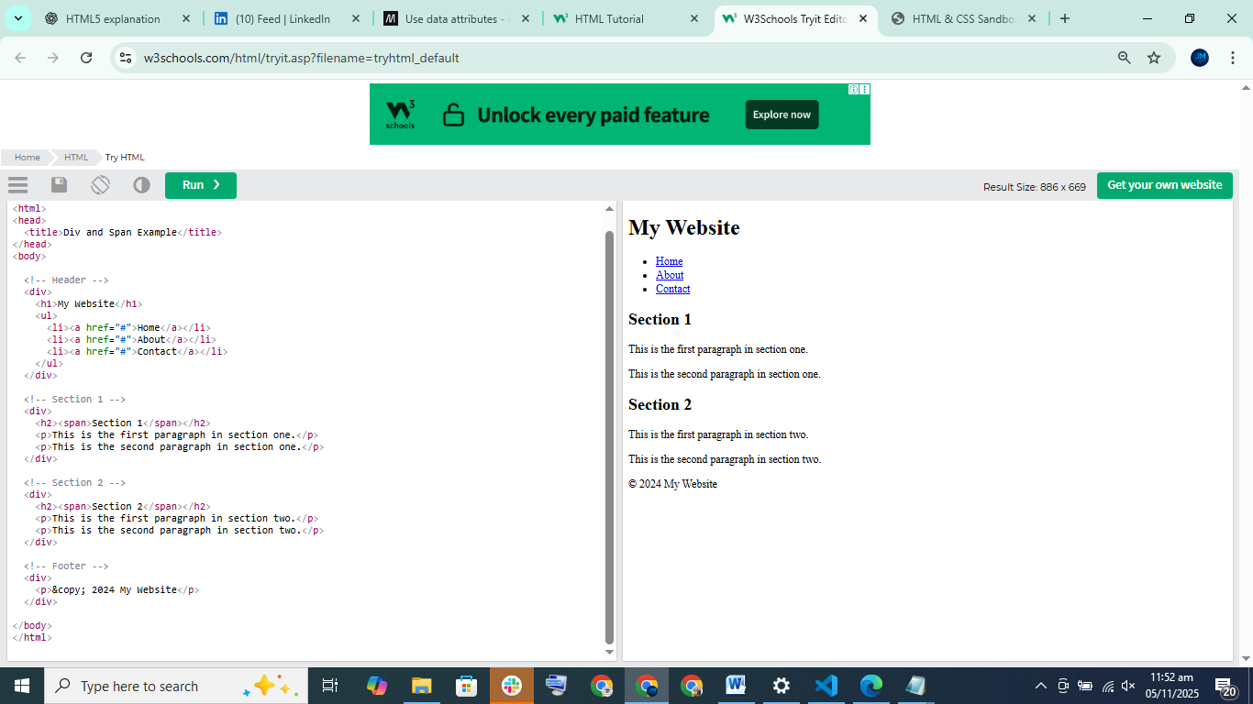

Vid 22

✅ What is Semantic HTML?
Semantic HTML means using HTML tags that clearly describe the meaning of content.
Instead of using <div> everywhere, HTML5 introduced special tags like:
Tag | Meaning
<header> | Top section / intro area
<nav> | Navigation / menu
<main> | Main content of page
<section> | Section of content
<article> | Independent content (like blog post)
<aside> | Sidebar content
<footer> | Bottom of page

✅ Why Semantic HTML is Important?
✔ Makes code descriptive & readable
✔ Helps search engines (SEO) understand your page
✔ Improves screen readers for accessibility
✔ Better for structure and web standards

✅ Example (Non-Semantic)
<div>
<div>Menu</div>
<div>Content</div>
<div>Footer</div>
</div>
This doesn't tell us what each part really is.

✅ Semantic Version
<header>Menu</header>
<main>Content</main>
<footer>Footer</footer>
Now it's clear ✅

✅ Key Points From Your Text
- HTML5 brings semantic tags to replace just <div>
- <div> & <span> = general containers (no meaning)
- Semantic tags = meaningful labels
- You can still use classes with semantic tags for styling
- Using semantic tags = good practice

🎯 Simple Real-Life Example
Bad:
<div id="top">My Website</div>
Better:
<header>My Website</header>
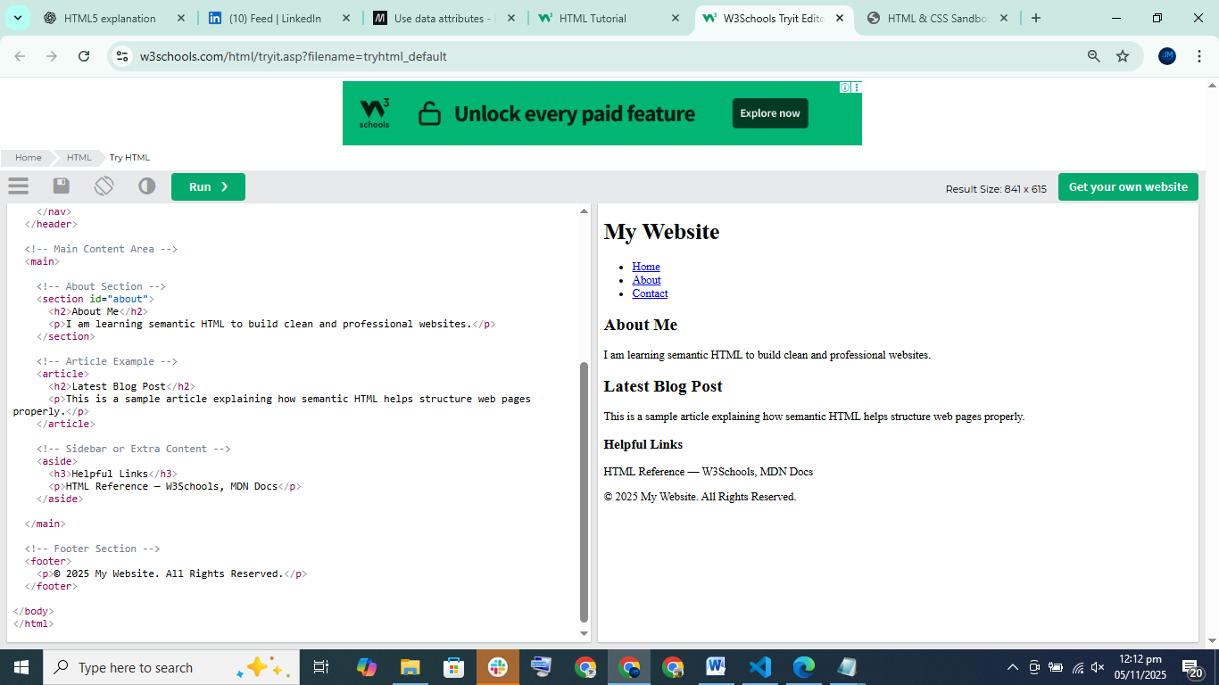

Vid 23 ✅ What You Learned (Emmet Crash Course — Easy Explanation)
Emmet is a tool in VS Code that helps you write HTML & CSS super fast using shortcuts instead of typing full code.
Example:
- p + Enter → <p></p>
- .title + Enter → <div class="title"></div>
- #main + Enter → <div id="main"></div>
- ul>li*5 + Enter → Creates a list with 5 <li> items
You can also:
- Add multiple classes → div.red.big.center
- Create nested tags → div>p
- Add text inside tags → p{Hello World}
- Auto numbering → li.item$*4 → item1, item2, item3, item4
- lorem → dummy text generator (e.g., lorem10 = 10 words)
- Add attributes quickly → a:link, script:src
- The ! shortcut generates full HTML boilerplate — also from Emmet

✅ Why Emmet is Useful
- Saves time typing HTML
- Helps build structure fast
- Great for practice & real projects
- Perfect for creating lists, forms, layouts quickly

📎 Memory Shortcut Table
Shortcut | Output
p | <p></p>
.box | <div class="box"></div>
#header | <div id="header"></div>
ul>li*3 | 3 list items
p{Hello} | <p>Hello</p>
lorem5 | 5-word dummy text
! | Full HTML template

📘 Summary (Easy Line)
"Emmet helps write HTML quickly using shortcuts like .class, #id, ul>li*5, and p{Hello} — saving time and improving workflow."

📎 Memory Shortcut Table
Shortcut | Output
p | <p></p>
.box | <div class="box"></div>
#header | <div id="header"></div>
ul>li*3 | 3 list items
p{Hello} | <p>Hello</p>
lorem5 | 5-word dummy text
!
Key board short cut for vscode vid 24
Here are the most useful VS Code keyboard shortcuts for daily coding 👇

✅ Basic Editing Shortcuts
Shortcut | Action
Ctrl + C | Copy line (if nothing selected)
Ctrl + X | Cut line (if nothing selected)
Ctrl + V | Paste
Ctrl + S | Save file
Ctrl + Z | Undo
Ctrl + Shift + Z | Redo
Ctrl + A | Select all
Ctrl + / | Toggle comment (single line comment)

✅ Multi-cursor & Selection
Shortcut | Action
Alt + Click | Add cursor
Ctrl + Alt + ↑ / ↓ | Add multiple cursors above/below
Ctrl + D | Select next match
Ctrl + Shift + L | Select all matches
Shift + Alt + Right Arrow | Expand selection
Shift + Alt + Left Arrow | Shrink selection

✅ Moving & Editing Lines
Shortcut | Action
Alt + ↑ / ↓ | Move line up/down
Shift + Alt + ↓ / ↑ | Copy line up/down
Ctrl + Shift + K | Delete line
Ctrl + Enter | New line below
Ctrl + Shift + Enter | New line above

✅ File & Window Navigation
Shortcut | Action
Ctrl + P | Quick open files
Ctrl + B | Toggle sidebar
Ctrl + Shift + E | Show Explorer
Ctrl + Shift + F | Search files
Ctrl + Tab | Switch between open tabs
Ctrl + Shift + T | Reopen closed file tab

✅ Command & Settings
Shortcut | Action
Ctrl + Shift + P | Command palette
Ctrl + , | Open Settings
Ctrl + K + Ctrl + S | Keyboard shortcut settings

✅ Terminal Shortcuts
Shortcut | Action
Ctrl + ` | Toggle terminal
Ctrl + Shift + ` | New terminal
Ctrl + C | Stop running terminal process

✅ Zoom / View
Shortcut | Action
Ctrl + = | Zoom in
Ctrl + - | Zoom out
Ctrl + 0 | Reset zoom
F11 | Toggle full screen

⭐ Bonus: Emmet (HTML Shortcut Examples)
Type | Output
! | Full HTML boilerplate
div.container | <div class="container"></div>
ul>li*5 | Create list with 5 items
Vid 25 project:
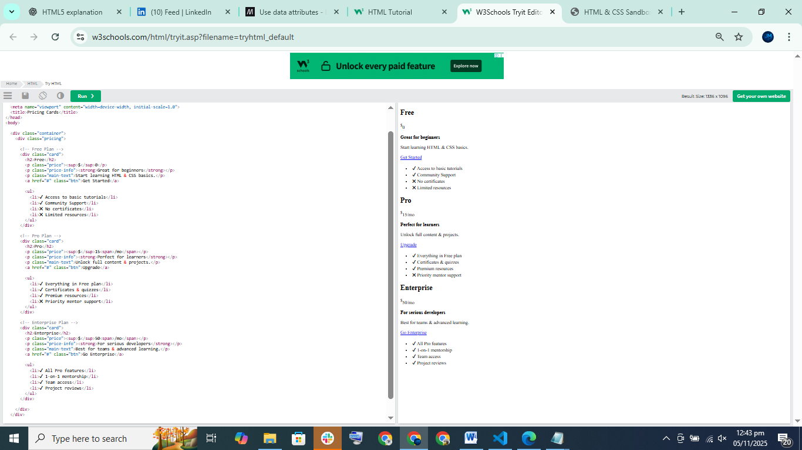

Next folder forms vid 27
This section explains HTML form tags and input elements, which are used to collect information from users on a webpage.

✅ Key Points Explained
- Forms in HTML are used to collect data from users
Examples: Login form, signup form, contact form, survey form
- HTML builds the form structure only
HTML collects & displays inputs, but does NOT process the data
(Processing is done via JavaScript or backend languages like PHP, Node.js, etc.)
- CSS styles the form
Example: button colors, input box design, spacing

✅ What You Will Learn in This Section
Topic | Description
<form> tag | Creates a form on a webpage
<input> types | Text, email, password, etc.
Form attributes | placeholder, disabled, required
Select box | Dropdown menu using <select>
Textarea | Large text field for messages
Checkbox | Allows multiple selections
Radio button | Choose one option from group
Date, color inputs | Special input types
Data lists | Auto-suggest drop-down list

<form> Tag Attributes
Attribute | Meaning
action="" | URL/endpoint where form data goes
method="" | How data is sent — GET or POST

GET vs POST
Method | Purpose
GET | Fetch data (URL shows data)
POST | Send form data securely to server
Forms can only use GET or POST

✅ Form Input Types Explained
Input Type | Use
text | Single-line text
email | Only accepts emails (browser checks format)
password | Hidden characters
number | Only numbers
textarea | Multi-line text (for long messages or blog body)
select | Dropdown list
date | Date picker
checkbox | Multiple select options
radio | Select only ONE option
file | Upload a file
submit | Submit form
range | Slider
color | Color picker
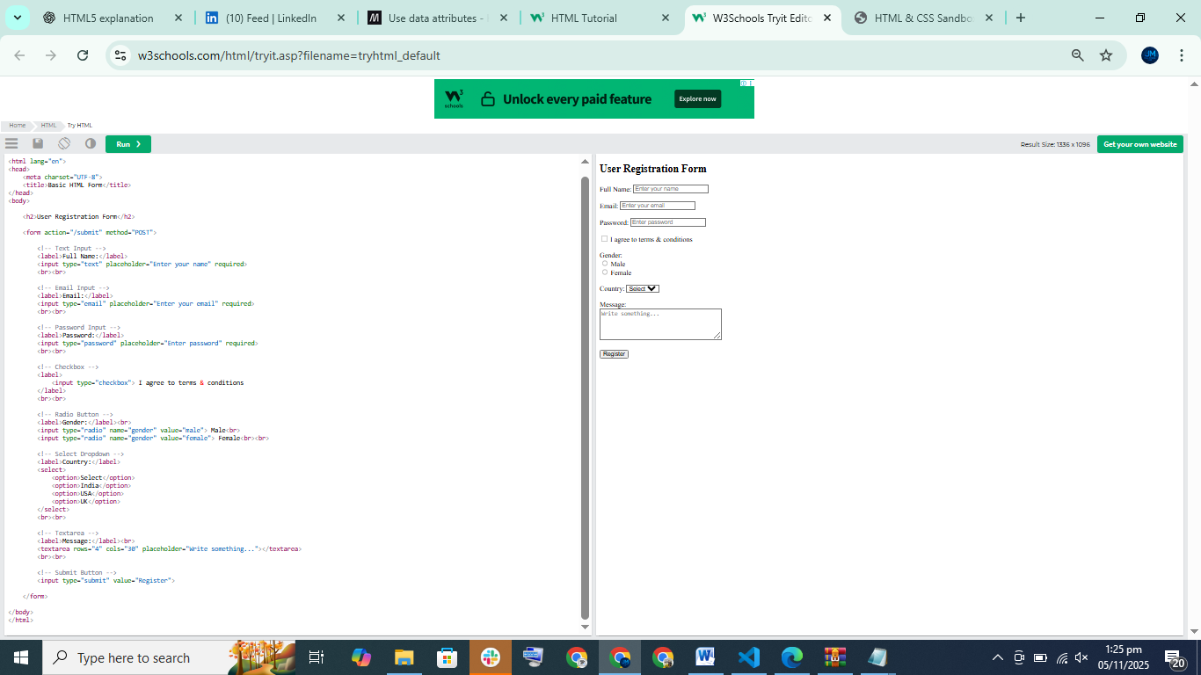

✅ Understanding HTML Forms (Easy Explanation)
In this lesson, we learned how to create basic HTML forms to collect user information like name, email, and password.
- The <form> tag is used to create a form.
- The form can send data to a server using the action attribute (but we didn't use it here because we are just learning HTML first).

✅ Input Fields
We used:
Type | Purpose
type="text" | For entering text like name
type="email" | For email input (checks valid email format)
type="password" | Hides text while typing (for passwords)

✅ Label Tag
- <label> describes the input field.
- The for attribute connects label to input using id.
- Clicking the label focuses the input field — good for accessibility.

✅ Block & Inline Behavior
- Labels and inputs are inline by default = same line.
- To move them on new lines, we used <br> OR wrapped each in a <div> (better practice).

✅ Submit Button
Two ways to submit the form:
<input type="submit" value="Register">
OR
<button type="submit">Register</button>
Both submit the form data.

🌟 Extra Learning Tips
- email input validates email automatically.
- Use id for every input and match with label for="".
- Better form spacing is done using CSS instead of <br>.
Vid 29

✨ 1. placeholder
Shows grey text inside the input before the user types.
<input type="text" placeholder="Enter name">
Purpose:
Helps users know what to type, especially when there is no label.

✨ 2. value
Pre-fills the input with default text.
<input type="text" value="John Doe">
Used when editing existing data (like editing a profile or blog post).

✨ 3. name
Very important for sending form data to the server.
<input type="text" name="username">
When you submit the form, this becomes the key:
?username=John+Doe
Without name, the input isn’t included in the form submission.

✨ 4. GET vs POST
Forms default to GET (data shows in URL):
?name=John&email=test@test.com
▶ GET — visible in URL, not secure
▶ POST — hidden, used for passwords/user data
Use POST for login, signup, payment forms:
<form action="process.php" method="post">

✨ 5. required
Makes input mandatory.
<input required>
Browser prevents form submission if empty.

✨ 6. minlength and maxlength
Restrict input length.
<input minlength="3" maxlength="10">
Useful for usernames, passwords, etc.

✨ 7. disabled
Locks the field — user can't change it.
<input value="test@email.com" disabled>
Greyed out → not sent with form.

🎯 Summary Table
Attribute | Purpose
placeholder | Hint text inside input
value | Default text inside input
name | Key used when sending data
method="post" | Secure form submission
required | Must fill before submit
minlength / maxlength | Text length limits
disabled | Field can't be edited

🚀 Coming Next Lesson
- Select dropdowns <select>
- Multi-line text input <textarea>
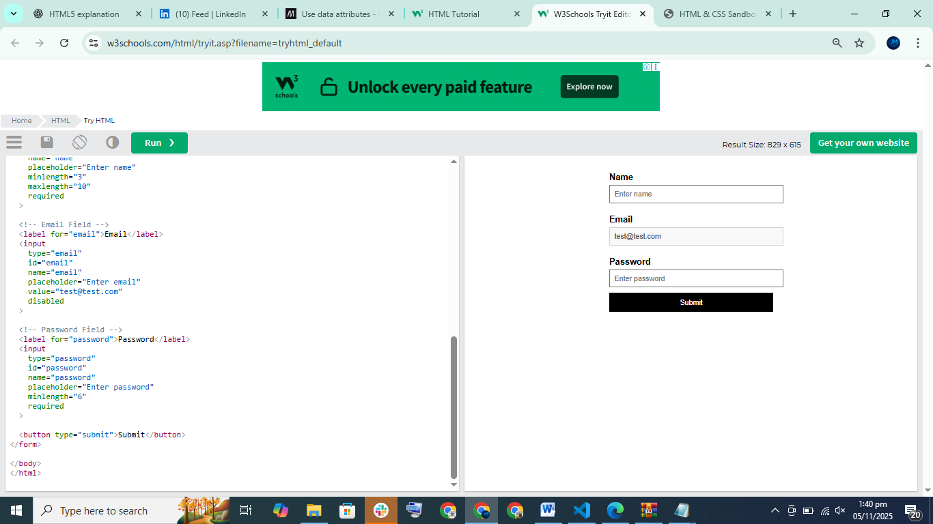

Vid 30

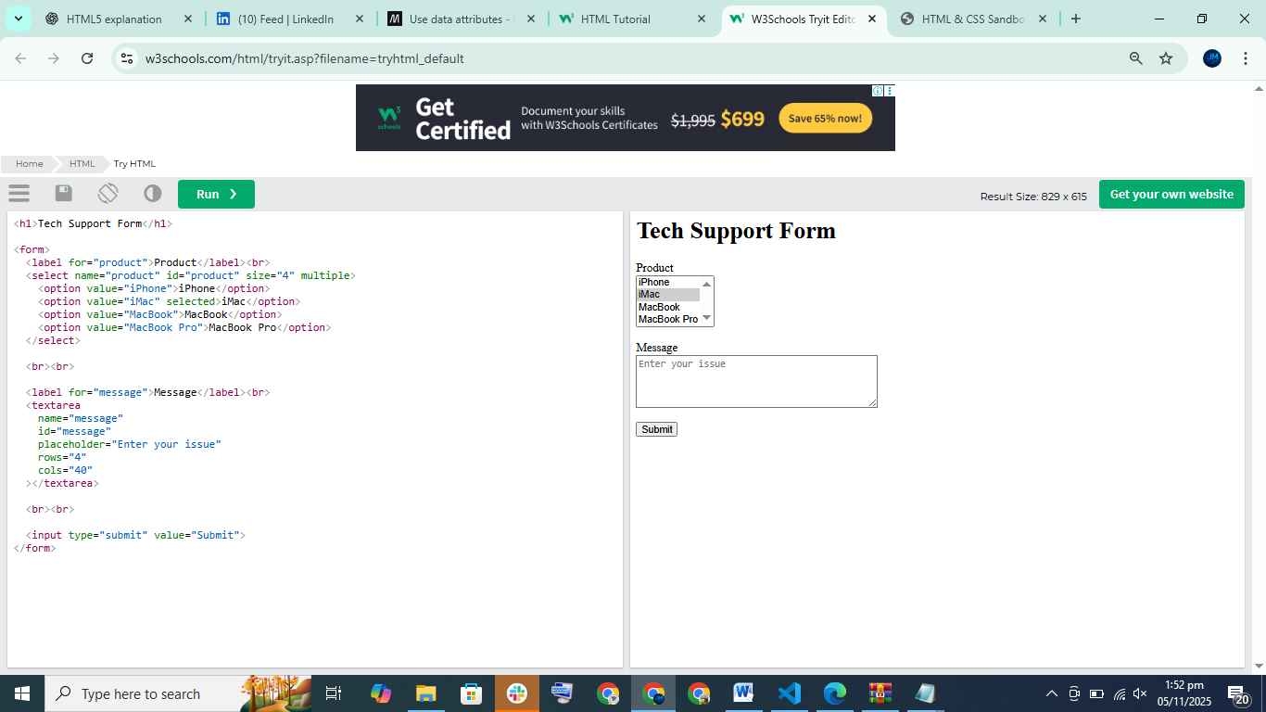Key Learning Points
Concept | Meaning
<select> | dropdown input
<option> | each item inside dropdown
multiple | select multiple options
size | how many options visible
textarea | multi-line input area
rows / cols | size control
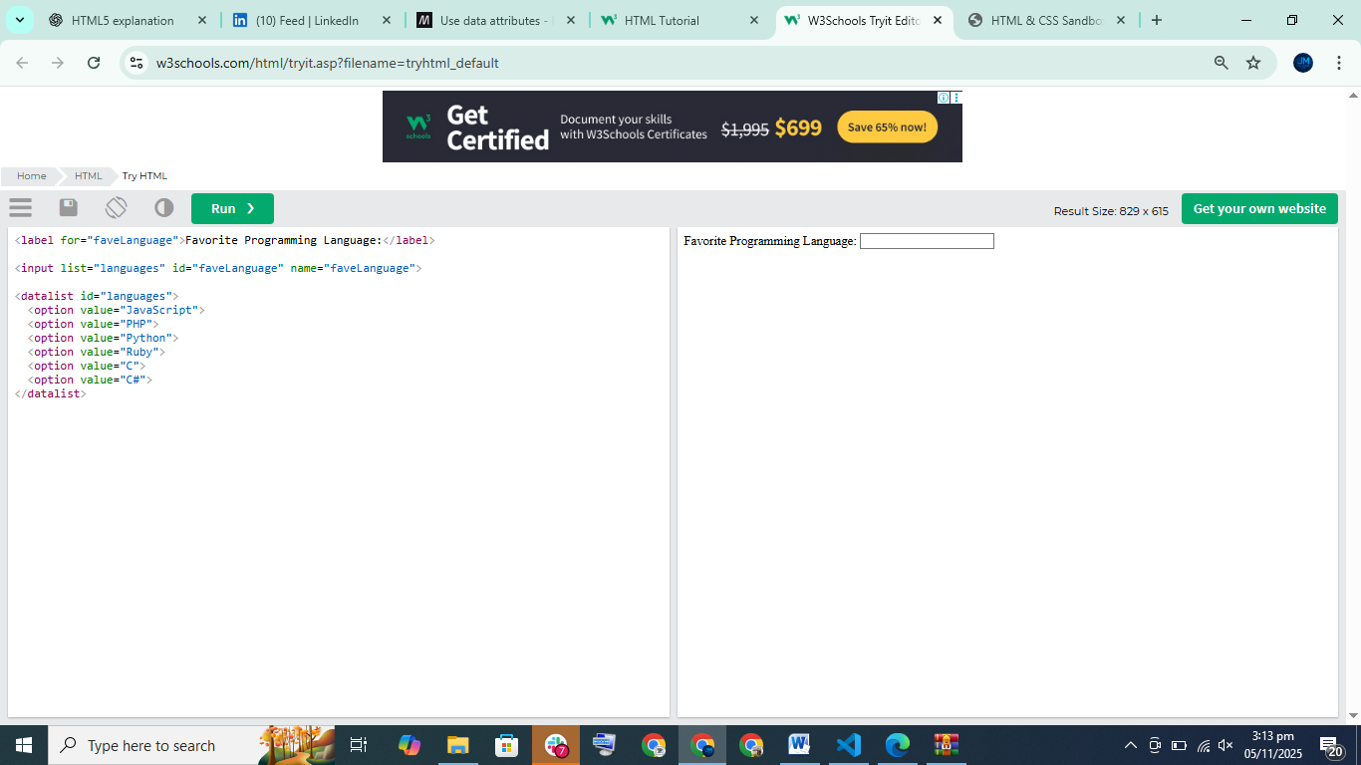
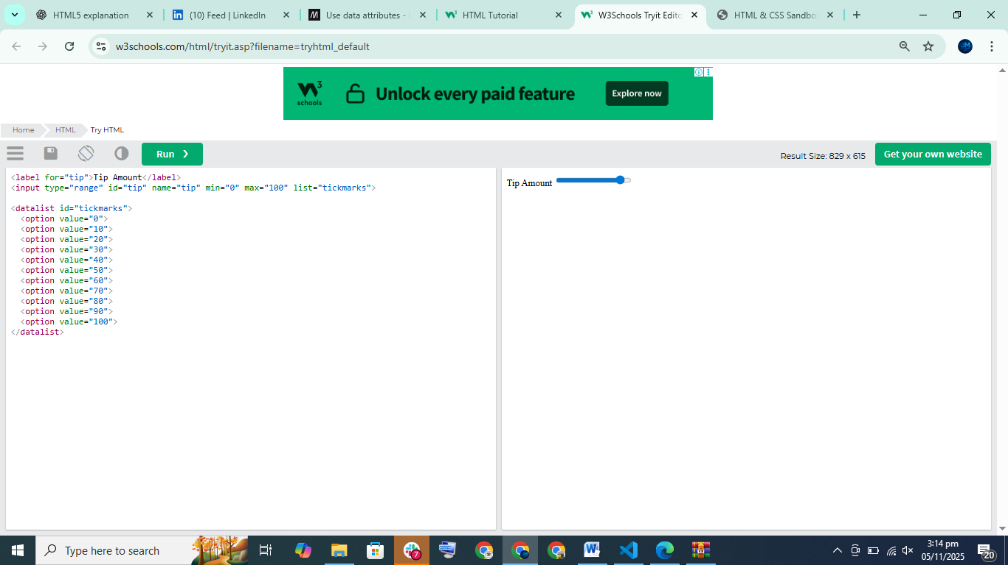

<!DOCTYPE html>
<html lang="en">
<head>
<meta charset="UTF-8">
<title>HTML DataList Examples</title>
</head>
<body>

<!-- General Datalist (Programming Languages) -->
<label for="faveLanguage">Favorite Programming Language:</label><br>
<input list="languages" id="faveLanguage" name="faveLanguage">
<datalist id="languages">
<option value="JavaScript"></option>
<option value="PHP"></option>
<option value="Python"></option>
<option value="Ruby"></option>
<option value="C"></option>
<option value="C#"></option>
</datalist>
<br><br><br>

<!-- Time Input With Suggested Values -->
<label for="timePick">Pick a Popular Time:</label><br>
<input type="time" list="popularHours" id="timePick">
<datalist id="popularHours">
<option value="10:00"></option>
<option value="11:00"></option>
<option value="12:00"></option>
</datalist>
<br><br><br>

<!-- Range Slider With Tick Marks -->
<label for="tipRange">Select Tip Amount:</label><br>
<input type="range" id="tipRange" name="tipRange" min="0" max="100" list="tickMarks">
<datalist id="tickMarks">
<option value="0"></option>
<option value="10"></option>
<option value="20"></option>
<option value="30"></option>
<option value="40"></option>
<option value="50"></option>
<option value="60"></option>
<option value="70"></option>
<option value="80"></option>
<option value="90"></option>
<option value="100"></option>
</datalist>
<br><br><br>

<!-- Color Picker With Suggested Colors -->
<label for="colorPick">Pick a Color:</label><br>
<input type="color" id="colorPick" name="colorPick" list="redColors">
<datalist id="redColors">
<option value="#81234F"></option>
<option value="#8B0000"></option>
<option value="#A52A2A"></option>
<option value="#DC143C"></option>
</datalist>

</body>
</html>
